Answer Key for Homework 4 (Due date: February 21, 2003)
- Notice that you are working alone for this homework. If I were you, I would start doing it ASAP even though you have lots of time. It will save you from last minute frustrations.
- Make sure to write your name and section number on each page.
- Staple everything together. Place it on the table with your section before class starts. There is a penalty of 5 pt. if you do not staple them together.
- Each question worth different with the total 100 pt. for the homework.

- Suppose the reaction temperature X (in °C) in a certain chemical process has a uniform distribution with a=-3 and b=7.
- write down the pdf of X,
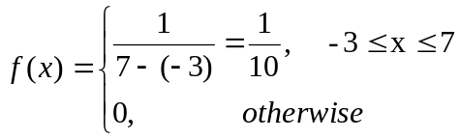
- write down the cdf of X,
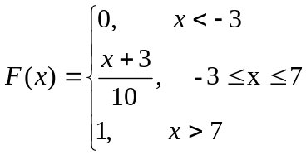
- Compute the median for X,
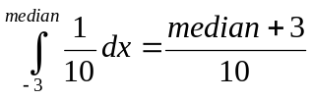 which is 0.5 then solve for median. Median=2

- Compute the 10th percentile for X.
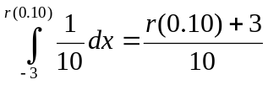 which is 0.1 then solve for r(0.10). r(0.10)=-2 which is the 10th percentile for X.

- Compute P(-1.5<X<1.8).
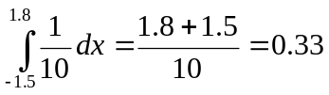
- For k satisfying –3<k<k+1<7, compute P(k<X<k+1)
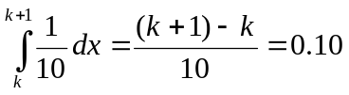
- Compute E(X).
E(X)=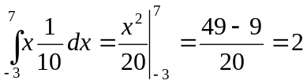
- Compute Var(X).
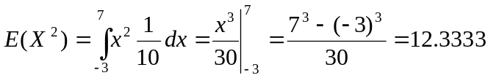
Var(X)=
- Compute E(5⋅X³). (Hint: h(X)= 5⋅X³ )
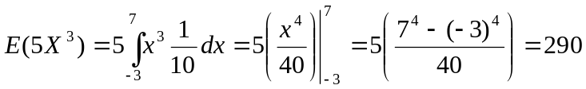

- Exercise 4.12
- P(X<0)=F(0)= 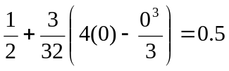
- P(-1 < X < 1)=F(1)-F(-1)= 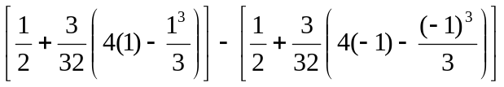=0.6875
- P(X > 0.5)=1-F(0.5)=1-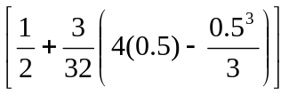=0.3164
- F’(x)= 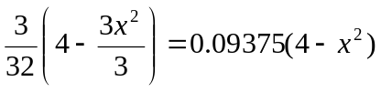
- Since P(X<0)=P(X≥0)=0.5 then median=0 using part (a). Alternative method is F(median)=0.5 then solve for median.

- In each case, determine the value of the constant c that makes the probability statement correct.
- P(0 ≤ Z ≤ c)=0.4649 then c=1.81
- P(Z ≥ c)=0.0022 then c=2.85
- P(|Z| ≥ c)=0.0044 then c=2.85

- Find the following percentiles for the standard normal distribution.
- 85th
P(Z≤z)=0.85 then the 85th percentile of Z is z=1.04
- 15th
P(Z≤z)=0.15 then the 15th percentile of Z is z=-1.04

- Let Z be the standard normal random variable and calculate the following probabilities.
- P(0 ≤ Z ≤1.9)=0.4713
- P(Z ≥1.9)=0.0287
- P(|Z| ≤1.9)=0.9426

- Exercise 4.35
(a) X~ N(25, 5²)
P(X ≤ x*)= 0.91 = P(Z ≤ (x*-25)/5) then (x*-25)/5=1.34 and x*=31.7

(b) P(X ≤ x*)= 0.06 = P(Z ≤ (x*-25)/5) then (x*-25)/5=-1.555 and x*=17.225

(c) X~ N(3, 0.15²)
P(X > x*)= 0.10 is the same as P(X ≤ x*)=0.90= P(Z ≤ (x*-3)/0.15) then (x*-3)/0.15=1.28 and x*=3.192

- Exercise 4.39
P(X>10.256)=0.10 then 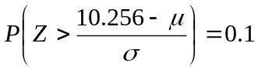. Using the table 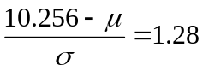
P(X<9.671)=0.05 then 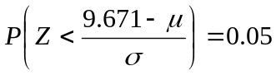. Using the table 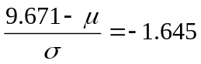
We have two equations and two unknowns μ and σ. If we solve for the unknowns, μ=10 and σ=0.2.

- Exercise 4.40
- P(|X-μ |≤1.5σ)=P(-1.5≤Z≤1.5)=0.8664
- P(|X-μ |≥2.5σ)=1-P(-2.5≤Z≤2.5)=0.0124

- Exercise 4.49 (notice that this is normal approximation to the binomial)
p: P(all drivers in a certain state regularly wear a seatbelt) =0.40
n=500 drivers selected
X: number of drivers regularly wear seatbelt ~ Binomial(n=500, p=0.40)

E(X)=np=500(0.40)=200
Var(X)=np(1-p)=500(0.40)(0.60)=120 then 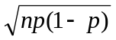=10.9545

(a) P( 180 ≤ X ≤ 230) = P(X ≤ 230) - P(X <180) = P(X ≤ 230)-P(X ≤ 179)
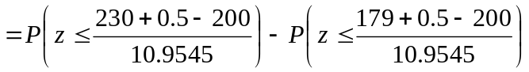=P(Z≤2.78)- P(Z≤-1.87)
= 0.9973 - 0.0307 =0.9666
(b) P(X<175) = P(X ≤ 174)= 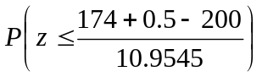= P(Z ≤ -2.33) = 0.0099
P(X<150) = P(X ≤ 149)= 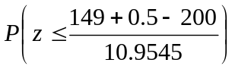= P(Z ≤ -4.61) = 0

- Exercise 4.53 (a)(b)
(a) 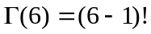 = 5! = 120
(b) 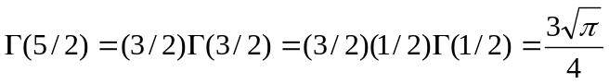 = 1.3293

- Exercise 4.55
X:time taken to mow the lawn ~Gamma (α=2,β=1/2) then X/β ~Gamma (α=2,β=1)

(a) P(X ≤ 1)=P(X/β ≤ 2) = 0.594
(b) P(X ≥ 2)=P(X/β ≥ 4) =1-P(X/β < 4) = 1 - 0.908 = 0.092
(c) P(0.5 ≤ X ≤ 1.5 ) = P(X/β ≤ 3) - P(X/β < 1) =0.801 - 0.264 = 0.537

- Exercise 4.92
X: the breakdown voltage ~N(μ=40, σ²=1.5²)
- P(39≤X≤42)= P(-0.67≤Z≤1.33)=0.9082-0.2514=0.6568
- P(X>x*)=0.15 then x*=?. First transform it to z and then look at the table.
x*=40+1.04(1.5)=41.56
- P(at least one exceeds 42)=1-P(all four does not exceed 42)=1-(P(X≤42))⁴=1-(P(Z≤1.33))⁴
=1-(0.9082)⁴=0.3197

- Exercise 4.98. Additional to the question, (d) what is the value of the median path length?
X ~ Exponential (β=1/λ=1/0.93) then f(x)=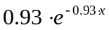, x>0.
P(X≤x)= 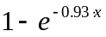
P(X>x)= 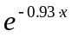
P(a < X < b) = 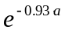-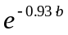

- If λ=0.93 then E(X)=1/0.93=1.0753 and also the standard deviation is 1.0753
P(X>3)= 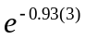=0.0614 and P(1 < X < 3) = 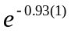-=0.3331
- P(X>x)= =0.10 then x=2.4759
- P(X>median)= 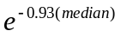=0.5 then median=0.7453

